**FOS (For Our Students)**

*Final Report*

**COSE472_Information Retrieval**

Team 23

Kyoungwon Kim (김경원)

**1. Development Environment _ Google cloud platform**

OS : Linux Debian 3.16.7 x86_64

Language: Python (ver. 2.7)

Library: Spark (ver. 1.5)

File system: Hadoop

**2. Purpose of the project**

Lots of students in universities experience hard times when choosing courses before the beginning of every semester. There are numerous courses and professors offered every semester and it is hard to find all those information that seem to be helpful. The choices that students currently have are either search courses on KLUE or ask others who have already taken those courses beforehand. KLUE is a website, which provides reviews of the courses in Korea University those evaluated by the students who have taken them.

Currently, there is no other system that recommends courses to the students and this is the reason why FOS has been created. It was not possible to have this kind of system back in the days when there was no data set containing all the lecture information or evaluations of them to be used to calculate the similarities or to find out the relationship among those information. It is now possible since we have a website, KLUE, where all those data that can be used for the purposes mentioned above can be collected.

This project is targeted for any students who have problem with selecting the courses they might be interested in based on the evaluations made by others through KLUE website. It is to recommend the courses those are similar to an input course code given by the user and show the graph relation and recommendation of courses, professors based on the evaluations that the user had given previously.

**3. How the system is formed**

When you are logged into KLUE website, it is possible to search for others’ review of a certain lecture by its course code, professor’s name, and name of the course. In order to understand FOS, it is crucial to understand the structure of KLUE webpage.

KLUE Website

Page

Page number, Semester, Year

Lecture info Student evaluation

Professor Numbered rating

Name of the lecture Text evaluation

Course code

Lecture Professor Student

Professor Lecture code (list) KLUE member number

Name of the lecture Courses that student evaluated

Course code

[Figure 3-1]

Each page in KLUE website consists of student evaluation(s) of a lecture given by a certain professor, in a certain semester and a year. With the data collected from KLUE website, FOS is recommending the courses those that are similar to the input course. The unit of the data is one evaluation of a student for one course. Each of the reviews is considered as one document in this system and was processed in order to get the results based on one course, not one document.

There are two parts in FOS to see the recommended data. One part is based on text evaluated data from the documents showing how similar other recommended courses are to the input course in bar chart and the other is shown in graph figure to show a visualized relationship between the user him/herself and other students who are “similar” to the user.

**4. Tools that had been used**

1) The Language that was used to calculate and get the similarities and relations between courses and users is python.

2) Spark is also an essential tool in the system since it made calculation of a large data set to be done in a very short time with python to be possible. There are certain reasons why spark was used in this project. First, even though the data collected from KLUE website cannot be considered as ‘Big Data’, large amount of data could be well-handled by spark. As it is stated in Github page for spark, it is a “fast and general cluster computing system for Big Data” and it surely made everything faster and convenient. Another reason is for the scalability of this project. KLUE has a rule for students who use the website which is that users must leave at least 3 evaluations every semester in order to use the system again for the next semester. Due to this rule, the amount of data that can be collected from KLUE increases steadily. The data is getting bigger and without spark it would be hard to process larger amount of data in the future. Another important thing is that with spark, the existing code can be used with even bigger sized data set.

The spark version used is 1.5 in this project.

3) Google server that is provided for free (for 60 days or up to $300) was used to run the spark code much faster with more than 1 cluster. It made the implementation to be more convenient and faster. There are 4 clusters, one master node and three worker nodes. For each cluster, there are two virtual CPU with 7.5G memory. The CPU used in the server is Intel Sandy Bridge and it has 50G SSD disk. The google server has the template for Hadoop and spark, which made the setup of the system not so difficult.

4) Finally, D3.js is used to visualize the result. It is a JavaScript library for visualizing data with HTML, SVG, and CSS. FOS has two kinds of results shown and they are displayed in forms of bar chart and a graph relationship.

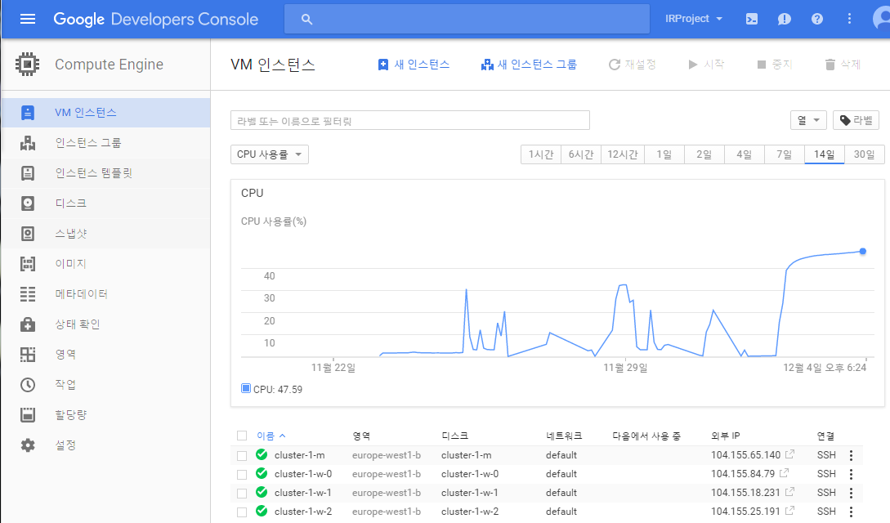

[Figure 4-1]

**5. How does FOS work?**

There are two parts of the result that users can get from FOS. The input of this system are a course code(학수번호) and member number, which is given by KLUE for each user. Each of those input gives different result. When a course code is given, a bar chart showing the similarities between the input course and top 10 similar courses that existed. When a member number is given as an input, the user can explore the relations between him/herself and other users that he or she is similar with. It shows not only the “similar” students but also the lectures that those students have taken and left high ratings in KLUE (4, 5 out of 5 maximum), the professors those who have given those lectures and the top-rated course that those professors have taught in the past and got high ratings in KLUE. 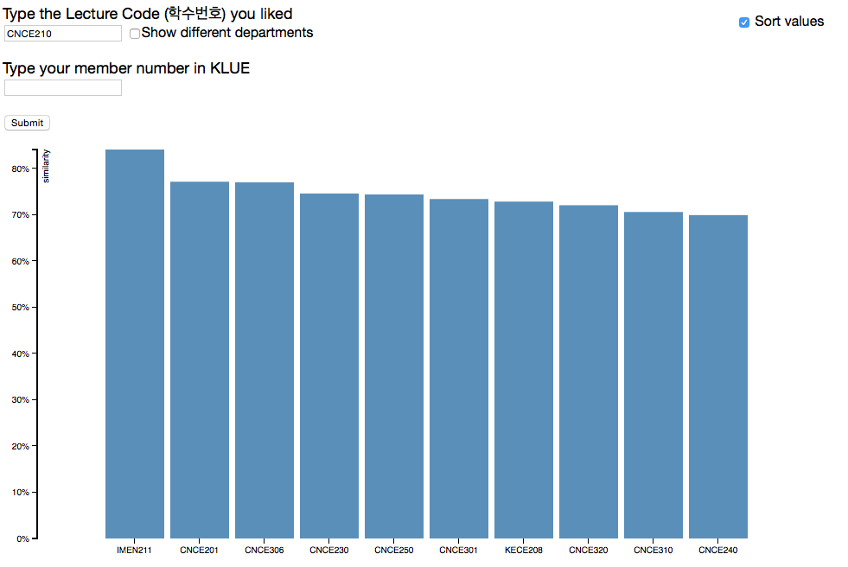 [Figure 5-1]

Figure 5-1 is the bar chart result when user type in CNCE210 (Data structure). As it is shown in the chart, more than half of the recommended courses are opened by the same department. It can be easily found out by checking first 4 letters of the course code, CNCE, since they represent the department where those courses are held. Additionally, for those people who want to get diverse results, a check box saying “Show different departments” exists. When you check the box and click submit, the result is shown like in Figure 5-2.

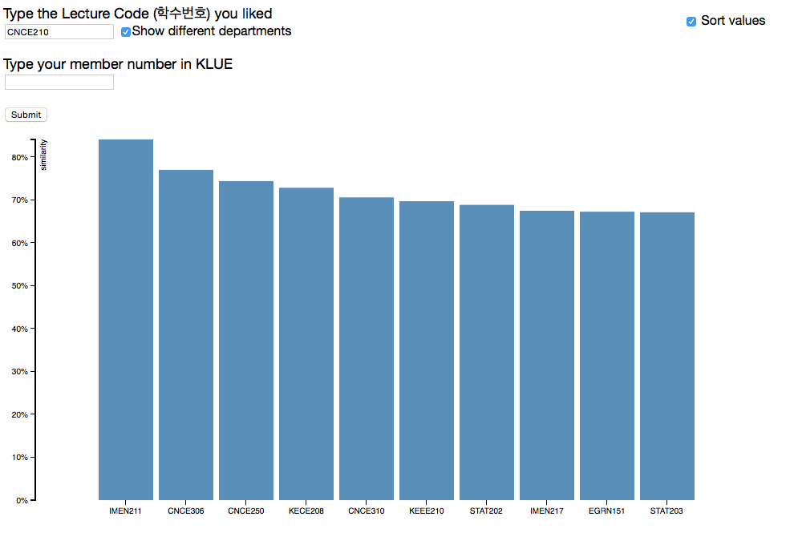

[Figure

5-2]

The number of courses those held by Computer Science department (CNCE) has decreased from eight to three. This function is useful when users are searching based on elective courses. Unlike the case when the input course code is one of those major, when the search is based on any electives, this function would be useful since courses held in different departments with similar reviews can be provided to the user.

The second type of result can be shown when a user’s member number is given.

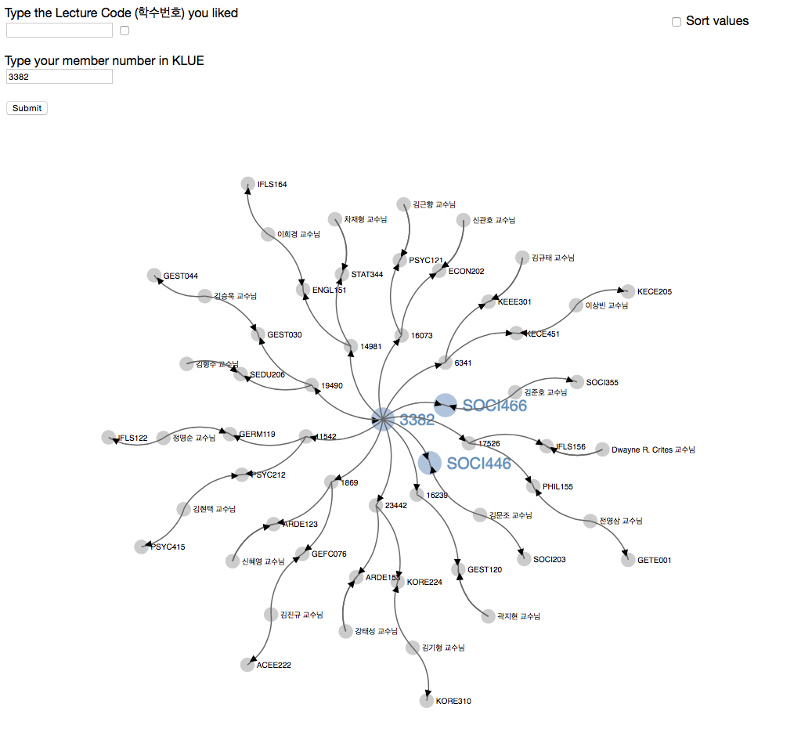

[Figure 5-3]

This result shows a person with member number 3382. The input user becomes the root of the graph and the nodes highlighted in Figure 5-3 are the lectures that this person had rated highly. The other nodes those connected directly with the input user are those students who are “similar” and each of them are recommending up to two courses that they liked. From these recommended courses, the professors who taught those lectures are branched out. Finally, those connected nodes from the professors are the top-rated course that each of them have taught in the past. Users can click the nodes to enlarge the letters on the web.

**6. How it is implemented**

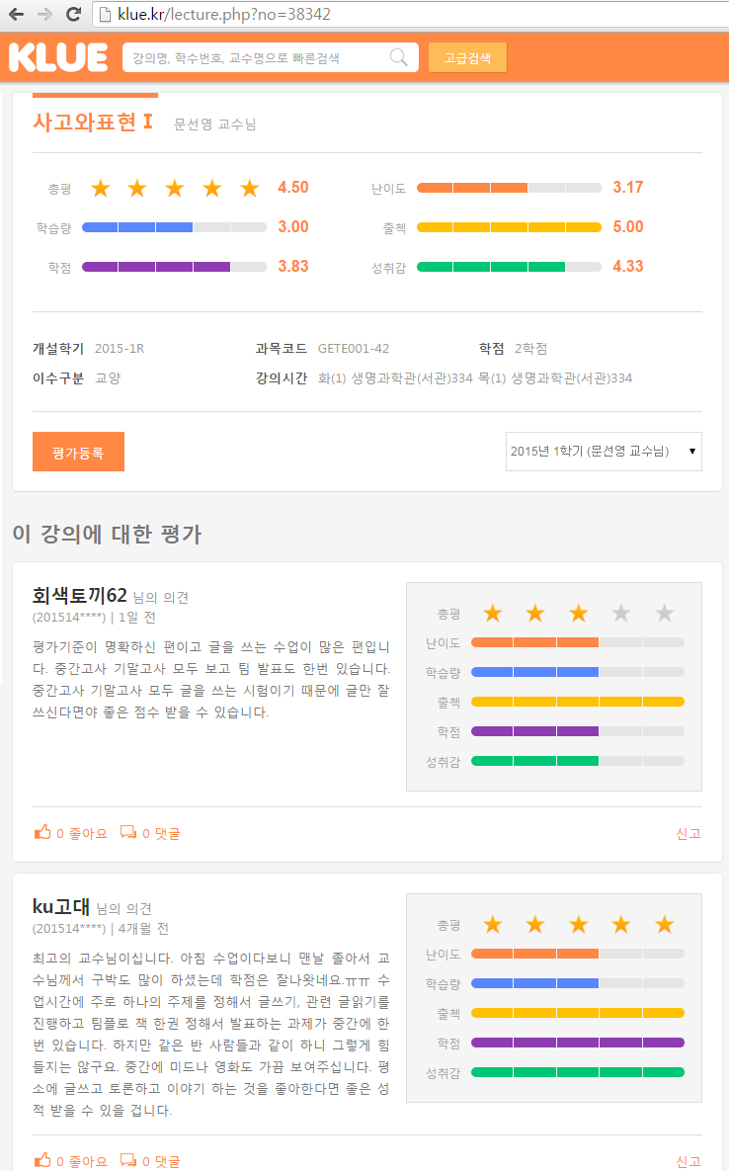Before explaining the algorithm behind each process, the terms need to be clarified. First, a course is all those lectures with same course code and a lecture is a class with a certain course code that has been held by a professor in certain semester, year. Another terms are page and document. A page in KLUE is where page information, lecture information and document(s) are included like Figure 6-1.

*Document*

*Page*

[Figure 6-1]

1. **Similarity between courses**

A course code should be given in order to get the recommendation from the system. The system shows a bar chart of top 10 courses those considered to be “similar” to the input course.

When KLUE data was collected, document was the unit of each json object. Since the page was not a unit, the information that page contains such as lecture information and the page information was included with each document object. Then, all the json file have been gathered into one big json file and saved as pickle file, which is an object file that spark can process much faster than usual json file.

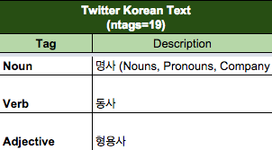In this part of the recommendation, the only data that was used to calculate the similarity between courses was the text evaluation in each document. The bag-of-words model was used to get the vectors used in K-Means algorithm and cosine similarity between existing courses. There were few thing that needed to be handled to process the documents. First part was to process Korean using KoNLPy library in Python. Since almost all the reviews are in Korean, in order to get proper result, Twitter class was used to stem all the terms and discard stop-words using Twitter tag function. Also, those terms that occur only once among all the documents were also discarded. Among several classes in the library, Twitter class is the only one that provides the stemming option and since it deals with twitter data, it’s enabled to handle those phrases that are not grammatically perfect.

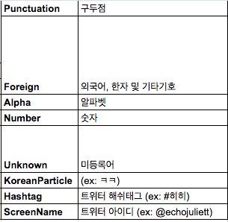



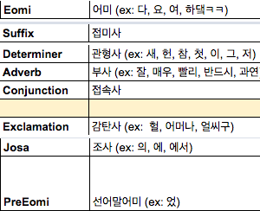



[Figure 6-2]

[u'Unknown', u'KoreanParticle', u'Hashtag', u'ScreenName', u'Number', u'Alpha', u'Foreign', u'Punctuation', u'Suffix', u'Eomi', u'PreEomi' ,u'Josa', u'Exclamation'], terms with these tags were classified as stop-words. After processing through all the documents, a term-document matrix was formed. Then it was normalized and transformed into tf-idf weight matrix.

With the tf-idf weight matrix, first, K-Means algorithm was implemented with 5 clusters. The cluster number was determined as 5 since the numbering evaluation could be from 1 to 5. Since text evaluations are supposed to reflect the numbered ratings, it was concluded that the number of clusters could be determined according to the numbered ratings. After the calculation, each document for certain course code was matched to a cluster. To make it clear, Figure 6-3 shows how clusters would look like in the case where there are 5 documents for lecture A, and 100 documents for lecture B.

Cluster 1 Cluster 2

A 2 A 1

B 20 B 30

Cluster 3 Cluster 4 Cluster 5

A 2

B 10 B 20 B 20

[Figure 6-3]

Since the calculation needs to be based on course codes not documents nor pages, a new matrix that would show the relationship between courses needed to be formed. The similarity using the clustered information can be shown as the equations below. In this equation c refers to cluster and S (i, j) means the similarity of lecture to lecture when the input is the lecture.

For instance, let’s assume lecture A is 0th lecture and lecture B is 1st lecture in the matrix in the example shown in Figure 6-3. The similarity can be summed up by looking at the match rate for each cluster between lecture A and lecture B when lecture A was given as the input of the system.

Using the equation above, the similarity would be

+ + = 1,

whereas the case when the input is lecture B, the similarity of lecture A to lecture B is

+ + = 0.233.

As it is shown in the example above, the relationship between courses can be simply and well-definably described into a probability using the given equation. By calculating all the similarity between every other courses, a matrix can be formed. The result was saved as pickle file named ‘cluster_sim’.

Another way to get the similarities between courses was getting cosine similarity between them. When forming the vectors that would be used in K-Means algorithm, each vector represented each document. However, in this case, each vector needed to represent a course since the cosine similarity between the vectors were going to represent the similarity that would be added with K-Means algorithm result. For this reason, a new matrix was formed where each vector represented a course. In order to form those vectors, the terms used in all the documents for each course were gathered and matched into a vector in term-course matrix. It was a way to look at those evaluations with same course code as one big document. Then the matrix was changed into tf-idf weighting matrix to calculate cosine similarity between the vectors. Since two vectors’ cosine similarity is calculated using dot product, it was easily implemented with Cartesian product between the tf-idf weight matrix the matrix itself. The result was saved as pickle file named ‘cosine_result_pickle’.

Both of the results were representing a matrix where each of the rows and columns represented a course. The final matrix which showed how similar those lectures are represented into one big matrix by summing up two matrices and saved into a pickle file named ‘final_result’.

As it is shown in figure 5-1, a bar chart is shown when the input is a course code with the name of top 10 similar lectures and the percentage of similarity. Since the course code is the input, the result of which courses are similar to the input course is saved into a .tsv (tab-separated values) file with the name of each course for every course existing. The percentage can be easily calculated since the maximum value of similarity score for both of the cases, K-Means algorithm and cosine similarity, was 1 and the minimum value was 0. The similarity value represented as percentage is the value of the matrix divided by 2.

Visualized result is in form of bar chart as it is shown in Figure 5-1. Top 10 similar courses are displayed and each of them is showing how similar they are to the input course.

A check box with a description saying “Show different departments” is also included for an extra function. When this box is checked and the input value is submitted, the result shows only those courses from different departments. In Figure 5-2, the input value was from Computer Science department and the bar chart still shows some of the courses from the same department. Currently, the result .tsv file for each course consist of top 100 courses those classified to be similar to the input course. Situations like Figure 5-2 can happen when there are less than 10 courses from different departments.

How accurate is the result using only text evaluations?

It was surprisingly accurate and it could be seen by looking at the result ourselves.

The screenshots below is top 5 results from ‘CNCE210.tsv’ and ‘CNCE342.tsv’, where CNCE210 is Data structure(자료구조) and CNCE342 was the former course code of Information Retrieval in Computer Science department. Just by looking at part of the result, it was interesting to find out that to a certain level, the similarities are properly determined.

|  |  |
| --- | --- |
| IMEN211 | 자료구조 및 알고리즘 |
| CNCE201 | 객체지향프로그래밍 |
| CNCE306 | 알고리즘 |
| CNCE230 | 논리회로설계 및 실습 |
| CNCE250 | 컴퓨터 구조 |

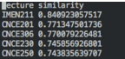

[Figure 6-4, ‘CNCE210.tsv’]

|  |  |
| --- | --- |
| CNCE330 | 인공지능 |
| CNCE340 | 컴퓨터 그래픽스 |
| CNCE320 | 데이터 베이스 |
| CNCE301 | 데이터 통신 |
| CNCE250 | 컴퓨터구조 |

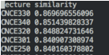

[Figure 6-5, ‘CNCE342.tsv’]

The weakness of using documents to calculate the similarity is when there are courses with no evaluations. Those would be ignored and will always get 0 result when one of them is given as the input course. Also, those courses will not be able to be included in graph results when similar students are recommending courses to the input user. Also one thing that bothered me before using the text evaluation data in KLUE was the reliability of the data itself. To show that the result that we get from calculating similarity between courses using text evaluation is reliable, I have conducted a very short sample survey about KLUE system among few students in Korea University. 34 students took the survey and were asked whether they themselves leave truthful evaluations and whether they fill up the text evaluation part truthfully. To the first question, 30 people answered that they give precise evaluations overall, and out of 3 people within those 30 persons answered that their text evaluation is not accurately written. Even though the sample is in very small size, it was shown that the text evaluation data have around 80% of reliability. Since the result that we get from the first method cannot be trusted with 100% of reliability, the second way of recommending courses using the relationships between users, courses, and professors was tried.

1. **Graph relationship with the user and other users**

The reason for including graph result into this system came from a very simple idea. The result using all the collected text evaluation data should always give same output to anyone who use the system. As a consequence, a simple idea that recommendation system should be considering personal interest led to show and recommend courses along with professors to the user.

As it was described before, the input needs to be the member number of the user given by KLUE to see the graph result shown in Figure 5-3. In this system, member number is different from student number. It can be easily obtained from KLUE when you are logged in. Any student’s member number can be obtained by clicking one’s nickname, then the number can be obtained from the URL.

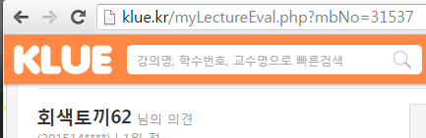

[Figure 6-6]

The graph is formed as the input user is matched to the root node. All the information that was needed was in a pickle file named ‘merged_file’, which was gathered when we first saved the web-crawled data. Using the data, first the course codes that students have rated either 4 or 5 on numbering evaluation part on KLUE were gathered into ‘user_lec’. Then the similarity between users were defined using the number of courses that both of them had taken and given high ratings. For instance, when a member number for student 1 was given as an input and that student had taken course A, B, C when student 2 had taken A, B, D, E, then in ‘user_user’ matrix, (student 1, student 2) would contain .

In the result graph, it is designed to show top 10 similar students. Once ‘user_user’ calculation was done, it became possible to find those students who seem to share similar interest with each user. The basic assumption to the graph recommendation is that those who have rated same courses with high value share similar interests. Based on this assumption, it can be assumed that the user might be interested in those lectures that the similar students have taken and rated high value. For example, if student 1 was defined to be similar to student 2 and the input of FOS was student 2’s member number, then course C could be recommended and be shown on the graph result. Let’s imagine student 2’s member number is 1001 which is the input value and student 1’s member number is 1002. Then the graph containing the information mentioned above would look like the figure below.

1001 1002 C

[Figure 6-7]

All the recommended lectures such as C in the Figure 6-7, are gathered as ‘fav_lecs’. As it was mentioned before, there can be lots of lectures for one course and the evaluations for all those lectures can differ depending on certain features such as professors who held the class for lectures. In this case, course C is the specific lecture C that student 1 has taken, not the course C in general like it was in K-Means algorithm result.

The next step was to show who taught those recommended lectures. Professors are considered in the graph relationship since, there are many cases where students had good experiences when taking the classes held by certain professors. Also, because students’ evaluations are including their opinion on professors, it could be concluded that if one had left high rating then it can be assumed that the student liked the professor. Furthermore, there is a high chance of that user liking other lectures held by those recommended professors. With these assumption, first the professors who have taught those recommended lectures were gathered as ‘fav_profs.’. Then calculating those lectures that those professors taught and were rated highly on KLUE by students was done. Since the data saved in pickle file was based on documents not the pages, first the average rating value of a lecture using all the documents that share the same page number was needed to be calculated. This data was saved into ‘page_eval’, then this result and ‘page_result’, which contains the page number and professor for that lecture, was joined to get ‘prof_page_eval’. To get the top 5 rated lectures held by those recommended professors, ‘fav_profs’ was joined with ‘prof_page_eval’ and formed ‘prof_best_pages’. Then by simply joining the gotten result with ‘page_lec’, each of those professors’ best rated page were translated into the lecture code in form of ‘prof_best_lec’ for user’s convenience.

Finally, the last two nodes added to the root node are the courses that the input user had evaluated highly. From those nodes, just like from recommended courses mentioned above, professors who held those lectures can be found and their best-rated course will also be seen on the graph. These connections are also shown since there are students who prefer to take the courses which are taught by those professors they have given high-ratings.

When the user had not given any reviews or did not rate any lectures numbered-ratings to be more than 3 then similarity calculation cannot be done by the system. All the cases where those kind of users are involved, user_user value will be 0 and since all the nodes of the graph starts with user_user, the graph for them will not contain any information. Another case where the graph does not contain all the information that’s been calculated in the code is when a professor’s top-rated course does not exist. This situation happens when there are no lecture that got highly rated by the students that’s been taught by the professor or when the recommended course that got him/her into that graph is the top-rated course.

**7. The future of FOS**

As it was mentioned in the beginning of the report, currently there is no system like FOS where the data that’s been formed by students themselves is used to recommend courses to the users. This project has developed into a level where it can give out recommendation of courses based on the input course and also give the users a chance to explore themselves within the users, lectures, and professors shown in the result graph when one’s member number is provided. There are numerous ways to bring this project to a whole new level.

0) The most important thing that was being considered when implementing this system was the environment of the system. It was the reason why the system was in google cloud platform and used 4 clusters. Since google cloud supports Hadoop and spark, it was convenient to run the codes efficiently and made this system to handle very large data. As mentioned in Tools section, spark is used in cluster computing and this gave FOS a strong power to handle Big Data, how the data set from KLUE can become in the future, with existing codes.

1. KLUE does not provide any API for log-in interface to other developers. As a result, FOS currently gets the student’s KLUE member number as an input when showing the graph. It is inconvenient and the privacy issue should definitely arise due to the face that once you are logged into KLUE, then you can view anyone’s evaluations by searching member’s number on the webpage. In the future, if KLUE managers strengthen security by encrypting those student information and provide log-in API, then it would be possible to do all the processes that FOS does to give out the graph relations with it.
2. For now, FOS is just for Korea University students since the data is based on KLUE. However, many other universities own their own course evaluation webpages that serve similar purposes. To extend FOS, it might be possible to gather all the evaluation data from those webpage. By doing so, spark and Hadoop can be properly used to handle and process through “Big Data”.

Not only that but also with enlarged data set, more meaningful information can be found and be extracted from them. For instance, it might be possible to find out what kind of lectures are popular among students by comparing data from past. Moreover, it can be extended so that by looking at the data, the most popular major of that time can be extracted or even be able to predict what kind of study will be leading the world in the future.

1. Currently, all the data must be stored in local memory after calculating the results. To publicize the system, server must exist but in this project, the cost of the server was not considered in the beginning of the project.
2. In the graph result, calculation is done based on lectures, not the courses. Therefore, it can be more generalized and improved by making it based on (course, professor) pair.

**8. Simple explanation of the codes**

**A. Files related to Web crawling**

a. crawl_ini.py: All the evaluations made through KLUE are gathered into json files in “**crawl_data**”

b. crawl_kuklue.py: Add course name, professor name information to the json file objects in “crawl_data”

c. merge_json_files.py: All the json files are merged into one big pickle file "**merged_file**"

**B. Kmeans**

a. tf_idf_kmeans.py: Using "merged_file", organize data into Dataframe and create tf_idf weighting matrix then saved into "**idf_kmeans**" pickle file. Using Twitter class in KoNLPy library, terms are stemmed and stop-words are discarded using the tags. Also, those terms that appear only once in the whole pickle file are also discarded.

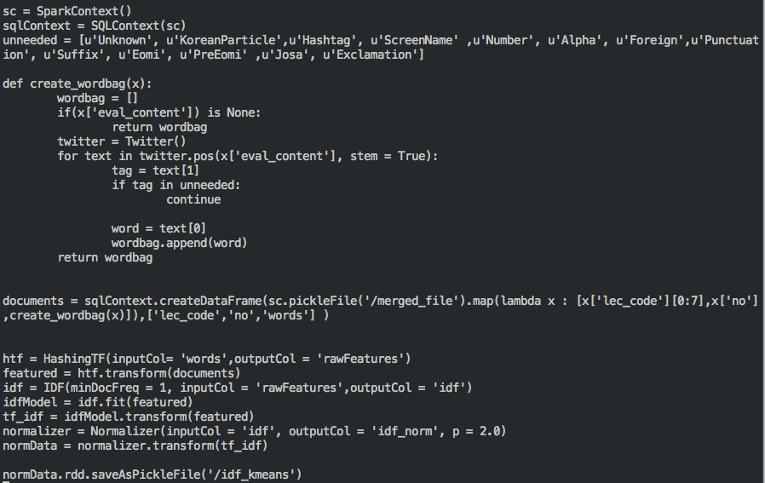

*In the code written above, function ‘create_wordbag’ is used to gather all the terms and form a list of them.*

b. KMeans.py: Using "idf_kmeans", train those data with KMeans algorithm where the number of clusters are defined as 5. The result is saved into "**KMeansModel**".

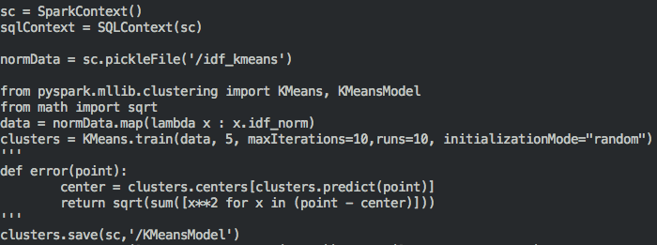

*With the library in pyspark, KMeans model is trained.*

c. KMeans_test.py: With "idf_kmeans" and "KMeansModel", with the logic described in the equation above, similarity between courses can be formed by doing Cartesian and the result is saved into a pickle file named "**cluster_sim**"

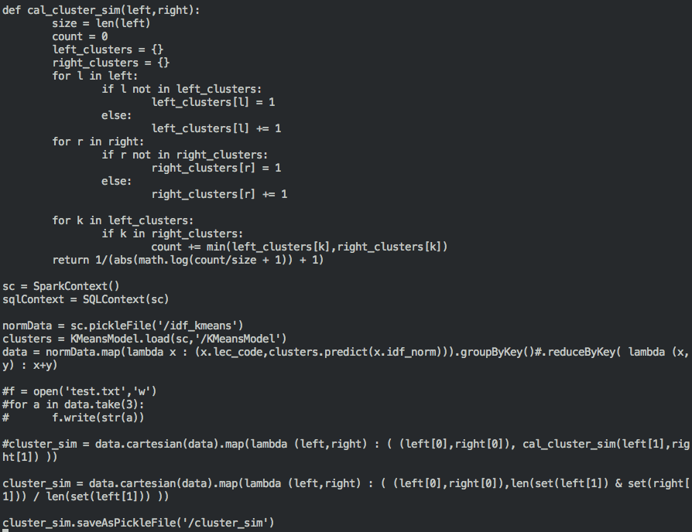

*Calculating similarity had been tried using ‘cal_cluster_sim’, then the method had been finalized using set operation.*

**C. cosine**

a. tf_idf_lec_code.py : A word bag is created for term-course matrix then the matrix is calculated into tf_idf weighting matrix and saved as a pickle file named "**idf_by_lec_code**".

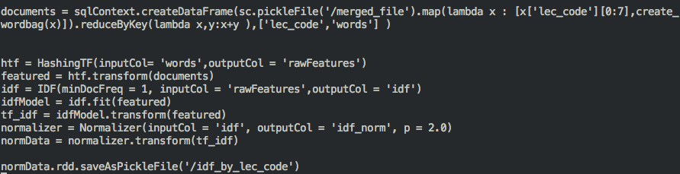

b. cosine.py: With "idf_by_lec_code", cosine similarity between courses is calculated and saved into a pickle file named "cosine_result_pickle".

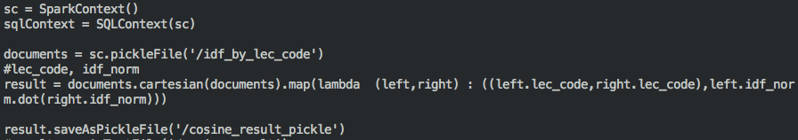

**D. rating_result**

a. rating_result.py: With the pickle files made in B.c and C.b, final result matrix is saved in a pickle file named "**final_result**".

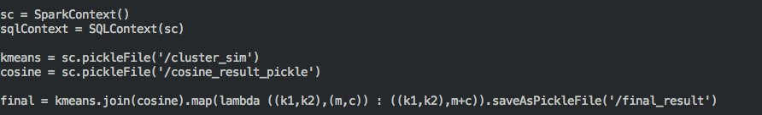

b. result.py: With "final_result", calculation for course similarity for each course is sorted in descending order than 100 top-rated courses are saved into .tsv format in './Similarity' folder in the name of each course.

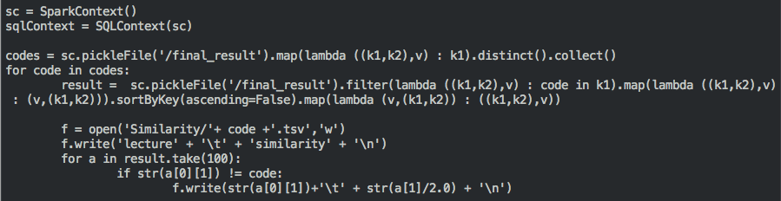

c. rating_result/Similarity: a folder where the similarity calculated results are saved for each course.

**E. favlist**

a. favlist.py: Using "merged_file", data is again organized into Dataframe named *user_df.* All the calculation in this code uses SQLContext functions in spark. First, all the data is collected that needs to be gathered from *user_df,*into*user_lec, user_page, user_nick, page_lec,* *page_prof, user_numbers, and page_eval.*Those are the data directly extracted from *user_df*. *user_lec* contains those course names that a user had evaluated highly (4, 5 out of 5 maximum value); *user_page* contains those actual lecture page, and highly evaluated score with user's member number; *user_nick* contains user's nickname for each member; *page_lec*contains page and course code information; *page_prof*contains information about the professor who taught certain lecture; *user_numbers* has all the member number existing in *user_df; page_eval*is the information of how each page is rated in average using all the documents. Then *user_user* is calculated so that the matrix contains how users are sharing similar interests by comparing what courses they have evaluated highly. Due to the fact that result using the relationship between users, courses, and lectures are shown based on a student's member number, the result of the calculation is saved for each member(student) into .csv format in "favlist**/data**" folder.

For each member, a list of users who are similar to the input user is calculated then the result is saved into rdd version named *fav_users*. The reason for changing data into rdd version is because the calculation needs to be done by spark. Then those pages that can be recommended to the input user are saved into *fav_pages*. Those are the lectures that *fav_users* have taken and rated highly, so on their point of view, they can recommend those lectures to the input user who seems to have similar interest with them. The result *fav_pages* is then transformed into *fav_lecs*, where the course name is saved instead of page number of KLUE for the user's convenience. If only the page number shows up in the graph, then the users of FOS need to check which lectures or what courses those pages are by searching KLUE themselves.

*fav_profs* contains the professors' names those who taught *fav_pages*. Then those professors' names are joined with the lecture code and saved as *fav_profs_by_lec*. With *page_eval*and*page_prof*,*prof_page_eval* is formed to have the information on how each lecture those professors taught are evaluated. Using this information, *prof_best_pages* is created and transformed into *prof_best_lec* where evaluations of the lectures of "fav(orite)" professors are sorted in descending order.

After all those calculation, data that needs to be included to make graph relation is saved into .csv format for each members of KLUE with his/her member number. The file contains top 10 similar students to the input member number; top 2 lectures that those students recommend; and for each of those lectures, professor who that lecture is shown and his/her top-rated lecture is also included. Using these files, the graph result will show with member number as an input.

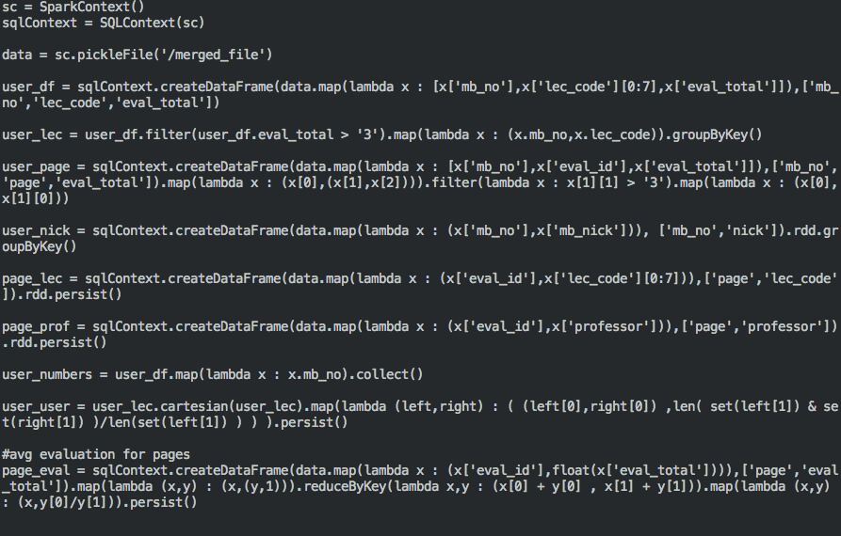

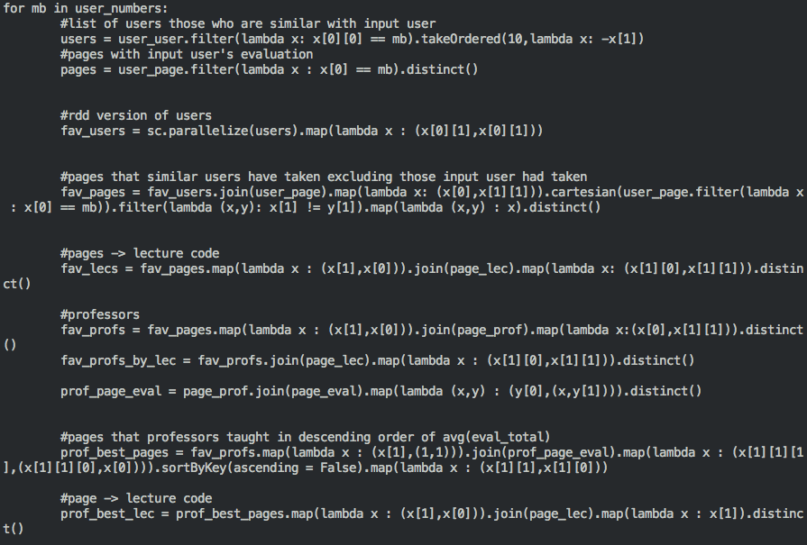



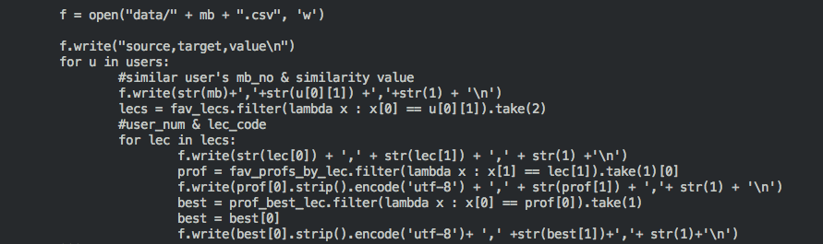

b. /data: a folder where graph relation results are saved for each member/student.

**F. HTML**

a. FOS_result.html: This code is where results are visualized with D3.js. It uses an open source library that we can access through web. <https://github.com/mbostock/d3>

Using sortable bar chart and basic directional force layout diagram, all the information is simply visualized through web.

* About the data:

Due to the size of the data, right now there are data for 103 member numbers and more than about 3000 course data is collected. When checking the result, please refer to the screenshot of the list of people and courses.

* Please open the html file with Safari:

When opening the html file, Safari needs to be used for security problem. This is because the html file needs to access local files. When other browsers are used, extra options need to be given so it is easier to open the file using Safari.

* + How to open with chrome?

In Mac OS, first close all the chrome webpages and applications. Then through terminal, type in the command below.

open -a Google\ Chrome --args --disable-web-security

In Window, end all the processes using chrome then through cmd, find the path where chrome exists. In the directory, type the command below.

chrome.exe —allow-file-access-from-files